Name: Amey Barbade, Roll no. 2403012
Experiment No. 3

GANTT CHART

Introduction
A Gantt Chart is a project management tool used to plan, schedule, and monitor the progress of a project over a specific period. It was developed by Henry L. Gantt in the early 1900s and is one of the most widely used techniques for project scheduling.

A Gantt chart represents project activities on a timeline using horizontal bars. Each bar corresponds to a specific task and indicates its start date, end date, duration, and progress. It helps project managers and team members understand what tasks need to be completed, when they should be completed, and how different activities are related to one another. The chart also makes it easier to identify delays, monitor project status, allocate resources efficiently, and ensure that the project is completed within the planned schedule.

In Software Engineering, Gantt charts are commonly used during project planning to divide the software development life cycle into manageable phases such as requirement gathering, design, development, testing, and deployment. By tracking each activity and its dependencies, the development team can maintain better coordination and complete the project on time.

Components of a Gantt Chart
A Gantt chart consists of several important components that help in planning and tracking the progress of a project.

- Task/Activity: A task is an individual piece of work that must be completed during the project. Each task is listed in chronological order on the left side of the Gantt chart.
- Timeline: The timeline is displayed at the top of the chart and represents the project's duration in terms of days, weeks, or months. It helps determine when each task starts and ends.
- Start Date: The start date indicates the planned date on which a particular task begins.
- End Date: The end date specifies the planned completion date of a task.
- Duration: Duration represents the total time required to complete a task. It may be measured in hours, days, weeks, or months depending on the project.
- Progress (% Complete): This component shows how much of a task has been completed. It helps project managers monitor the project's current status.
- Milestone: A milestone is a significant event or checkpoint that marks the completion of a major phase of the project. It has no duration and is usually represented by a diamond symbol in a Gantt chart.
- Dependencies: Dependencies indicate the relationship between tasks. Some tasks cannot begin until previous tasks are completed. This helps maintain the correct sequence of activities.
- Task Bar: A task bar is the horizontal bar used to represent the duration of each task on the timeline. The length of the bar indicates how long the task will take.
- Resource Assignment (Optional): This component identifies the person, team, or department responsible for completing a particular task.
- Status Indicator: Some Gantt charts include a status indicator (such as On Schedule, Delayed, or Completed) to quickly show the current state of each activity.
- Critical Path (Optional): The critical path is the sequence of tasks that directly affects the project's completion date. Any delay in these tasks will delay the entire project.

Advantages of a Gantt Chart
- Provides a clear visual representation of the entire project schedule.
- Helps in effective planning and scheduling of tasks.
- Makes it easy to track project progress.
- Clearly identifies task dependencies and sequence.
- Improves communication among project stakeholders.
- Assists in efficient resource allocation.
- Helps identify delays and take corrective actions early.
- Ensures timely completion of project activities.

Disadvantages of a Gantt Chart
- Becomes difficult to manage for very large or complex projects.
- Requires frequent updates when project schedules change.
- Does not represent task complexity or effort in detail.
- Can become cluttered if too many tasks are included.
- Does not automatically resolve resource conflicts.
- Creating and maintaining detailed Gantt charts can be time-consuming.

Planning of ChargeSure Platform Using Gantt Chart
The Gantt chart for the ChargeSure AI-Powered EV Charging Management Platform outlines the complete development timeline of the project, divided into five major functional phases mapped to our Scrum Sprints: Authentication & Vehicle Profiles, Station Aggregation & Prediction, Booking & Route Planning, Battery Intelligence, and Complaint Triage & Admin.

Each phase is further divided into specific tasks with defined timelines, allowing the development team to systematically track the project from initial setup to full feature completion.

1. Project Planning & Setup (Initial Phase)
This foundational phase focuses on requirements gathering, studying existing EV charging solutions (literature survey and case study), and designing the initial database schema (User, Station, Booking, and History databases).

2. Sprint 1: Authentication & Vehicle Profiles
This phase establishes the core user access and profile system.

- Setup Frontend & Backend architecture.
- Implement User Registration via Google OAuth.
- Develop the Vehicle Profile module to allow drivers to select EV models and specify battery capacity.

3. Sprint 2: Station Aggregation & Prediction
This phase focuses on centralizing charging network data and implementing the core AI availability logic.

- Setup the Station Database.
- Build the Unified Map displaying aggregated stations.
- Implement Search & Filters (network, connector type, power rating).
- Implement Predictive Availability Engine.
- Implement Ghost-Station Detection Module.

4. Sprint 3: Booking & Route Planning
This phase introduces the primary transactional features for the driver.

- Implement Slot Booking system.
- Implement Booking Cancellation logic.
- Develop the Wait Time Estimation logic based on predicted capacity.
- Build the AI-assisted Route Planning module suggesting optimal charging stops.

5. Sprint 4: Battery Intelligence
This phase focuses on personalized, vehicle-specific insights.

- Develop the Charging Time Estimator based on vehicle profile and charger power.
- Implement the Battery Health (SoH) tracking module using historical session data.
- Build the Transaction History dashboard.

6. Sprint 5: Complaint Triage & Admin Dashboard
The final development phase builds the operational tools for station operators and admins

- Develop the Complaint Reporting Module.
- Implement the NLP Triage Classifier for urgent alerts.
- Build the Operator/Admin Analytics Dashboard.

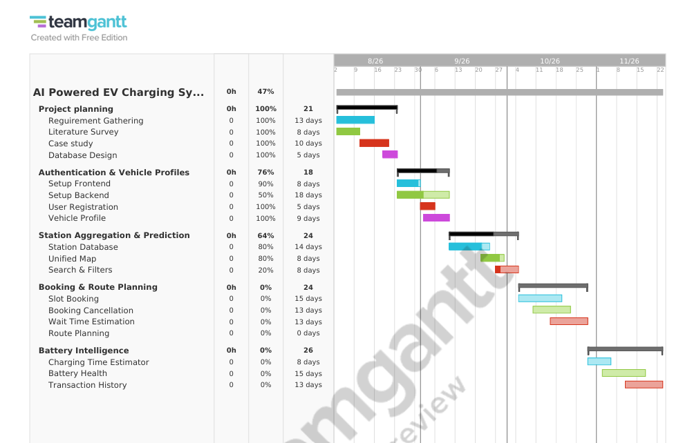

15-Day Development Schedule Gantt Chart
